AATC_Drone

This module is a reference implementation for a communication system between a drone and a server. It provides an interface object with which the logic of the drone can communicate using defined functions such as login , check for flights etc. This is preferable to a direct socket access version as this version provides all necessary functions and can be extended where necessary while reducing the complexity of the drone logic code by only requiring simple function calls to an object which will handle any errors and raise any exceptions required to reset the system without blocking the main logic thread if a network connection were to fail, meaning any attempt to connect will end in failure. Furthermore this module provides the drone logic with a variety of functions to convert messages from the server into simpler python objects.

Import

The module imports 7 modules. Socket, codecs, ast and recvall are required for the correct functioning of the socket. Sys is required for the sys.exit() functionality. AATC_Crypto is required to encrypt the communications between the server and the drone. AATC_Coordinate is required for the creation of coordinate objects.

DroneInterface

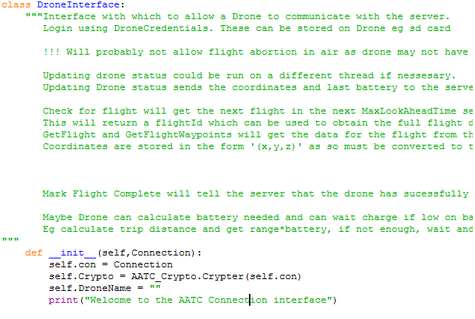

The DroneInterface class is used by the drone logic module to communicate with the server. The class wraps around a socket and exposes a number of functions used to access common commands to the server. When instantiated the object takes a connection object which is connected to the server. The connection is then stored in the ‘con’ variable to be accessed by the class later. A AATC_Crypto.Crypter object is then created which establishes the encryption parameters for the session and the object is stored in the crypto variable. Drone name, a currently unused variable is set to an empty string.

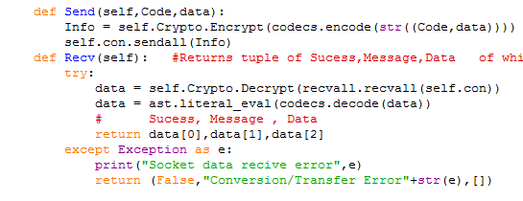

The Send and Recv methods are used to send and receive messages from the server. The Send method takes the command and the data to be sent to the sever and places these into a tuple which is converted first into a string, then a byte string and finally encrypted using the AATC_Crypter object. This data is then sent to the server via the sendall method of the socket.
The Recv method does not take any explicit parameters. Using a try/except statement to catch any exceptions the method receives data from the socket and converts it back into it’s original form by decrypting, decoding and converting to a python representation using the ast.literal_eval function. This tuple of returned data is sliced into three blocks to be returned success, message and data. If an error occurs the exception is caught using the except statement. The error is printed on screen and a failure message is returned to the program showing that there was an error.

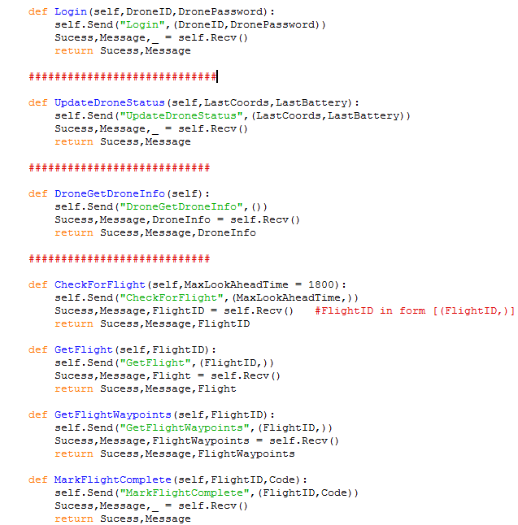

The login method of the Drone interface takes two explicit parameters , the DroneID and the DronePassword , integer and string respectively. The method sends the login command to the server using the send procedure with the two parameters and obtains a response, returning this response to the caller.

UpdateDroneStatus takes two parameters, LastCoords a tuple containing the last coordinates of the drone and LastBattery a float with the last battery level of the drone. The function sends the UpdateDroneStatus command to the server and receives a response and returns this to the user.

DroneGetDroneInfo takes no parameters and obtains the information about the drone. The function does not need the DroneID as if the drone is logged in then the server knows the ID of the drone already. No other drone can be looked up as this would require the user’s credentials which should not available to the drone in case the drone were to be lost/stolen so that the credentials of the user would not be compromised.

Check for Flight takes one optional parameter called MaxLookAheadTime, an integer. This variable controls how far into the future the drone should be allowed to accept a flight i.e. start the flight early if drone is not busy. Check for flight will search for the closest flight which has a start time within MaxLookAheadTime seconds of the current time. It will return the flightID of the flight if one is found and returns this to the user.

GetFlight takes one integer parameter FlightID. This function requests details about the flight required to perform the flight e.g. start time, ETA and distance. It returns the details of the flight to the caller.

GetFlightWaypoints takes one integer parameter FlightID and obtains all the flight waypoints for that flight and returns the details to the caller.

Mark Flight completed takes two integer parameters, FlightID and code. FlightID is the FlightID for the flight to be marked complete while code is the completion code for that flight. The details are sent to the server and a success and message response are returned to the caller.

Flight

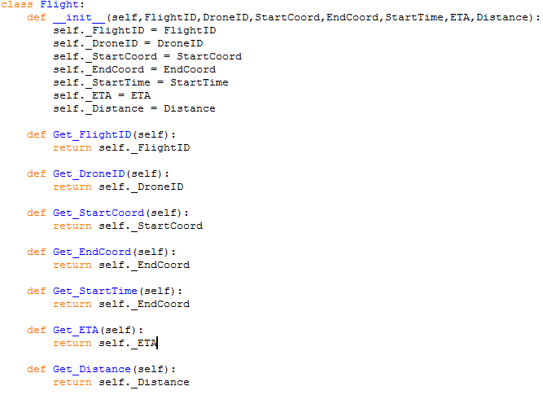
This object provides a simple way to store the details of a flight without resorting to unstructured dictionaries or indexing lists. The object stores information about a flight and the information about the flight can be obtained by using the classes methods. Each attibute is used to store one piece of information about the flight, and although they are not typed, the variables should contain the following types:
FlightID = integer, DroneID = Integer , StartCoord = Waypoint, endCoord = waypoint, StartTime = float or integer , ETA = float or integer, Distance = float or integer.
StartTime, ETA and Distance can be either integers or floats as the way they are processed will be handled in the same fashion. It is up to the server to decide what format should be used.

The method format is simple, Get_X(self) returns self._X. Setting of variables is not required.

Waypoint

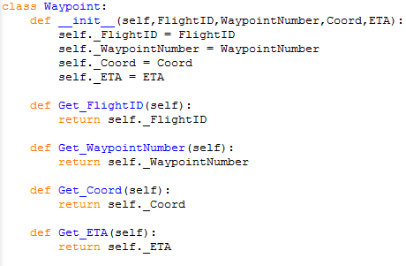
The waypoint class contains the details for each waypoint of the flight. As with the Flight object is designed to only store data for easier access. The variable types are as follows: FlightID = Integer, WaypointNumber = Integer , Coord = AATC_Coordinate.Coordinate, ETA = Integer or float.

ConvertCoordString

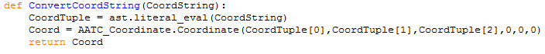
This function is used to convert a string representation of a coordinate into an AATC_Coordinate.Coordinate object. The form of the string should be “(x,y,z)”. The string is converted into a tuple using the literal_eval function and the x,y,z values is position 0,1,2 of the tuple are used to create a Coordinate object which is then returned to the caller.

GetFlightObject

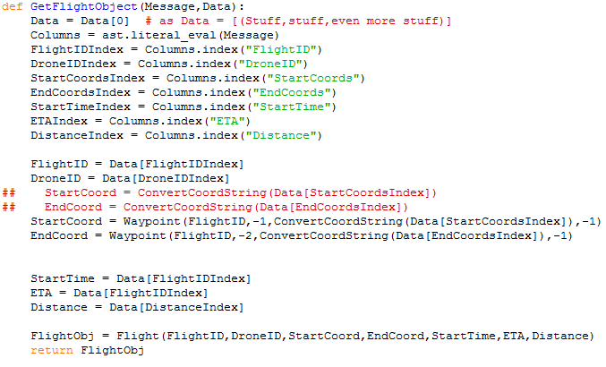

This function takes two arguments , message and Data , string and list respectively. The outer list is removed ( as it is a list of tuples) to obtain the tuple only. The message is converted into a list using the literal_eval in order to obtain the names of each column and their positions. The index of each item is obtained and the Flight and Drone IDs are obtained. The start and end coordinates are converted and used to create waypoints with waypoint IDs of -1 and -2 respectively (instead of coordinate objects to simplify the code for Drone_Logic. StartTime,ETA and Distance are obtained and used to create a Flight object. This object is then returned.

GetWaypointObjects
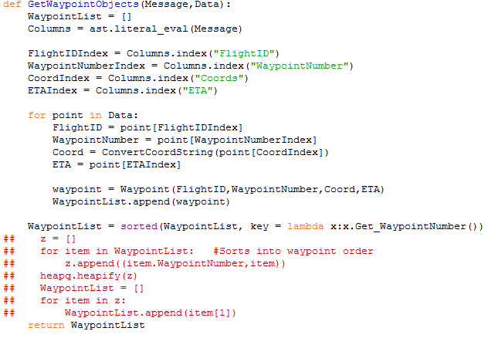

This function is similar to the GetFlightObjects function, taking two arguments Message and Data (string and list) and creating a number of objects from these variables. This function converts a list of waypoint tuples into Waypoint objects. The list in which the waypoint object will be stored is initialised and the message is converted into a list using the literal_eval function. The indexes for the columns are found and stored in the relevantly named variables. Then for each item in the list of data points the program obtains the flightID, Waypoint number , coordinate and ETA. The coordinate is converted using the ConvertCoordString function into an AATC_Coordinate.Coordinate object. Finally the waypoint object is created using these arguments and stored in the list. The waypoint list is sorted into ascending waypoint number order so that the Drone_Logic can iterate through in the correct order (otherwise may pass through each waypoint, however in a non linear order.

MakeDroneInfo

This function acts as a temporary way to pass information to the initiation of the DroneInformation object and probably will be removed.

DroneInformation

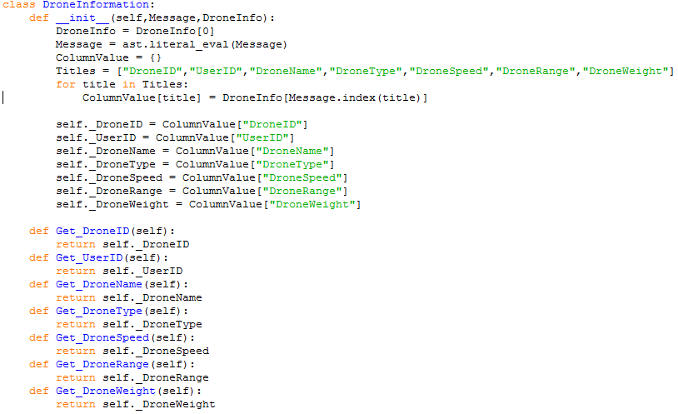

The DroneInformation object stores information about the drone i.e. speed, range, weight etc. Although not strictly necessary for an actual drone the object is required in order to allow the simulation of the drones to run correctly as the simulation must know the speed of the drone and it’s range in order to calculate the distance moved per unit time and the battery consumption for each iteration. If implemented into an actual drone these functions could be used to limit the maximum speed the drone would fly at or prevent the drone from flying without a given reserve battery level.

When instantiated the object takes a string message and list DroneInfo arguments. The DroneInfo tuple is created from the DroneInfo list and the message is converted into a list using literal_eval. A list of titles of the columns required is used to create a dictionary of values for each column, which are then used to create the attributes of the object.
The Get_X methods simply return self._X.

Connect and CreateDroneInterface

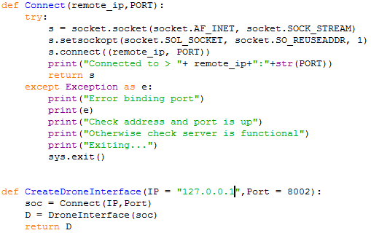

The Connect function attempts to connect to the remote IP on the specified port. In a try/except clause the program creates a socket and sets the socket to have a reusable address, meaning that if the socket closes unexpectedly i.e. due to a network failure the address can be connected to again before the TCP port times out. Finally the socket is connected to the address and the connection object is returned. If the connection fails then the program will print that the connection failed and close the program (closure may be removed).

The CreateDroneInterface function takes two optional arguments , IP a string and Port and integer, and connects to that address while creating a DroneInterface instance using that connection and returns the interface to the caller.

